MIS REPORT
1 | Name of the candidate | Vaibhav Rajput |  |  |  |  |  |  |  |  | 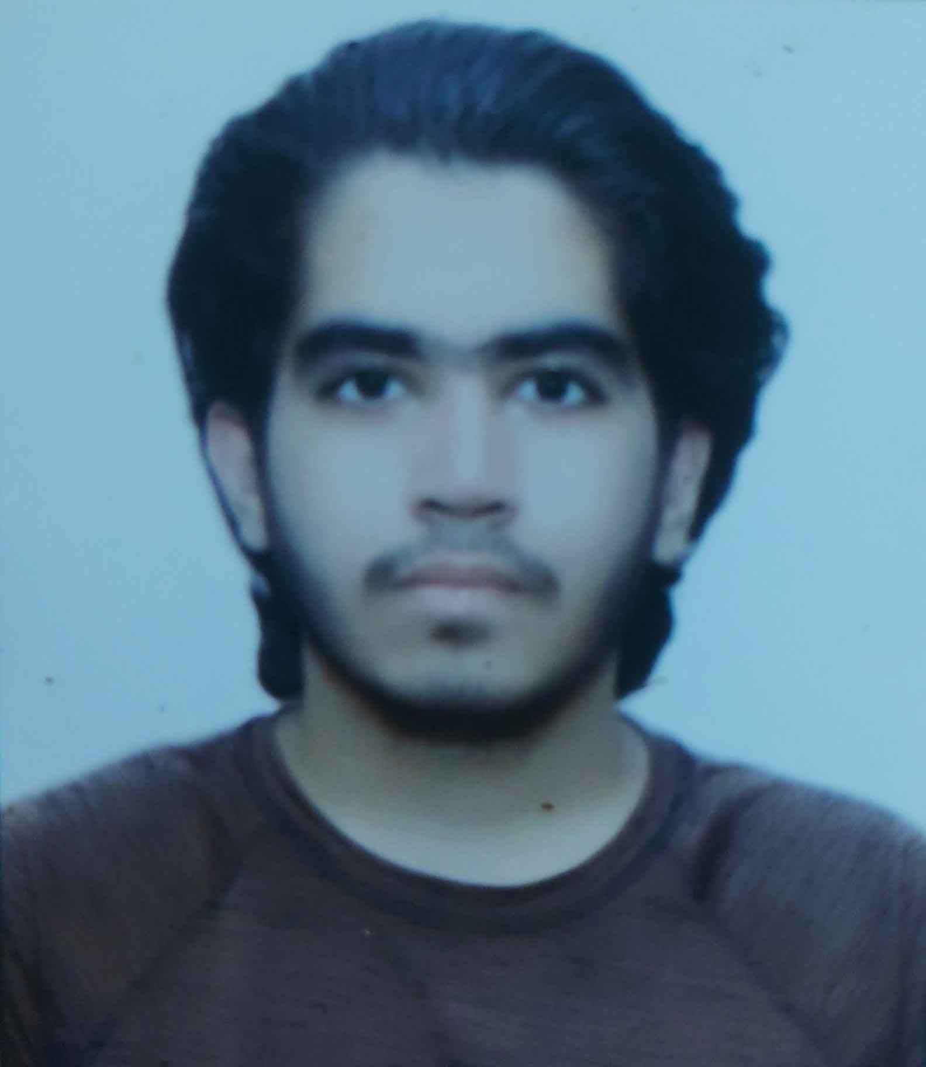
2 | Father / Husband’s Name | Mr. Sanjeev Kumar
3 | Gender | Male
4 | Date of Birth | 24/08/2000
5 | Mobile no. / E-Mail ID | 9911463592
6 | Alternate Mobile no of family members(Mention relation and no) | 8744969547 (brother)
7 | Marital Status | Single
8 | Permanent Address | WZ – 1090 B Back Side, Basai Dara Pur, New Delhi - 110015
9 | Present Mailing Address | WZ – 1090 B Back Side, Basai Dara Pur, New Delhi - 110015
10 | PAN / AADHAR No (Mandatory) | DXCPR6885J |  |  |  |  | 6111 5533 6275
11 | Are you a member of EPF / ESI  If so, specify | No
12 | Qualification | Btech CSE
13 | Nationality | Indian
14 | Religion | Hindu
15 | Caste | Rajput
16 | Category (Please Tick) | SC |  | ST |  | BC |  |  | MBC | OBC |  |  | GENERAL
17 | Experience in Brief | -
18 | Details of Family members (Father, Mother, Spouse and Children)
18 | Name | Relationship |  |  | D.O.B |  |  | Nature of Job/Business |  |  |  | Income  (Per month)
18 | Mr. Sanjeev Kumar | Father |  |  | 31/12/1972 |  |  | Govt. Job
18 | Mrs. Sushma Kumar | Mother |  |  | 10/01/1977 |  |  | House Wife
18 |  | Spouse
18 |  | Son / daughter
18 |  | Son / daughter
19 | Languages Known | English and Hindi
20 | Blood Group | B+
21 | Details of past association if any with STAR | Health Insurance Policy (ongoing)
22 | Details of relatives working / worked in STAR | NA
23 | Details of relatives working / worked in hospitals/TPA/other Insurance companies | NA
24 | Are you facing any criminal case/convicted by any court? | NO
25 | Are you facing any specific health issues? | NO
26 | Are you differently-abled? | NO |  |  |  |  |  | If yes, please provide disability certificate.
I hereby declare that the information furnished above is true and correct.
Place: New Delhi Date: 20/04/2022 Signature of the candidate: Vaibhav Rajput

